
SEVERN ROAD CLUB
Hinton Hill Climb - Course UH90
Saturday 12 October 2024 - Start time 2:30pm
Promoted for and on behalf of Cycling Time Trials under their Rules and Regulations

www.severnroadclub.co.uk
Event Secretary:  Neil Blessitt  51, Everest Road  Fishponds  Bristol BS16 2DA | Timekeepers  Bridget Boon  Ian Boon

Please note that the start sheet is found on the “start sheet” tab on the CTT website. The main hill climb event for adults follows directly after the Juvenile event (there are no entrants this year). A copy forms part of this document, below.

Headquarters, Start area and Parking

The HQ for this event will be located in or next to the field being used as the event car park.

The start is next to the car park of “The Bull at Hinton” pub. This is about a minute’s ride from the event car park.

Car Parking is located in a field to the south of the road between Hinton and Pucklechurch. Look for the large triangle of grass to your left (if heading west towards Pucklechurch) as you leave Hinton village. Turn left, and take a right at the far end of the triangle. Parking is in the field, through a gate on the right. In the event of heavy rain you may be asked to park next to the field. Look out for signage. Please make sure you park as directed, leaving a decent width between you and the adjacent vehicle.

The field will be signposted with arrows. Under no circumstances should you park at The Bull pub –parking is reserved for pub customers only.

Pucklechurch and Bristol are to the left / west of the map.
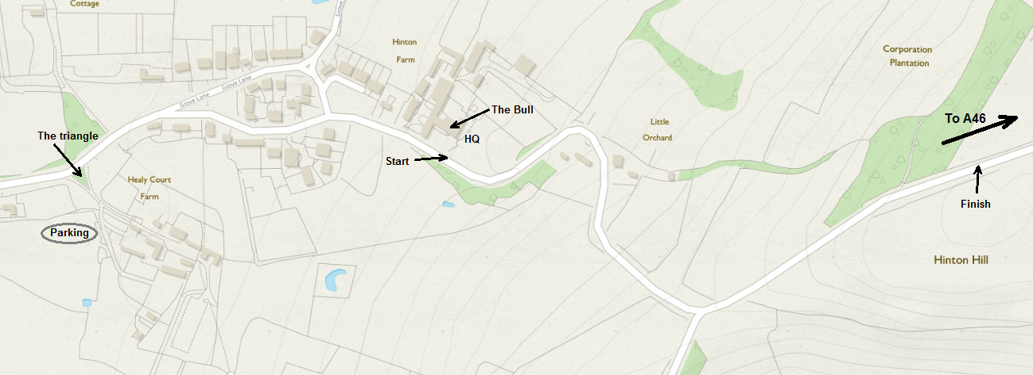

PLEASE NOTE; The HQ will be next to the car parking, NOT at The Bull

Address for “The Bull”: Hinton, Chippenham, SN14 8HG.

Toilets

Richard, the Landlord of The Bull kindly allows us to us the pub toilets. Please use the side entrance (Half-way along the right hand side of the pub) rather than the front one which would take you through the bars.

Food

The Bull provides very nice food as well as drink. If you would like to eat there after the event (or before!) then Richard advises you to order in advance via the pub’s website. The menu can be found at thebullathinton.co.uk

Numbers.
Riders must sign the signing on sheet at the HQ to obtain their race number and check for any last-minute information. Please don’t forget to also sign out and return your number. If the weather is very poor, please remember that your number must be visible at all times.

Course details
START: At the base of Hinton Hill next to the pub car park. Finish is at the crest of the hill just outside of the trees and adjacent to the large road sign that you can only see the back of (approx ½ mile). See map above.

Course records:

Fastest woman: 2:20.5 Anna Fischer, Maxgear RT, 2010.
Fastest Juvenile: 2:01.7 Finlay Hawker, VC de Londres, 2020
Fastest Junior: 1.53.3 Matt Fratesi, SRC 2015
Fastest Senior: 1:47.8 Rob Gough, Artic Sram RT, 2011

SAFETY
Although the Covid situation at the time of writing is much better than in the past three years riders are asked to take care and, in particular note the following points:
- If you feel unwell, or you have been in contact with someone who has Covid please stay at home. We want to be able to run this event again in the future so we don’t want to upset local residents by appearing to be irresponsible. Thank you.

In addition, CTT guidance reminds us that riders should not exceed speed restrictions. This is part of riding and racing safely. Riders in West District must not exceed speed restrictions and should not over take other road users unless it is safe to do so. An example would be overtaking a slow-moving vehicle such as a tractor, where the road is wide enough.

Other safety issues:

- As per CTT regulations you must display a white front light and a red rear light. You will not be able to start without these.
- Please arrive at the start no sooner than 10 minutes before your start time.
- When racing, keep left at all times, particularly on the first bend to the right after 100m.
- Be aware of cars entering and leaving The Bull at Hinton car park
- Take care when descending the hill after you have finished. There are a number of sharp, blind bends, so please ensure that you don’t cut these corners whilst descending.
- If you stop at the junction half way up the hill to cheer people on, or friends and relatives intend to do the same, please be very careful not to impede traffic wanting to pull out. This junction will be marshalled.
- Refrain from turning around on the race course
- CTT recommends that competitors wear a hard shell helmet that meets an internationally accepted safety standard.
- All juniors/juvenile riders MUST wear protective hard shell helmets
- We hope to have refreshments available after the event but to be sure please aim for self-sufficiency. As above, you will be welcome at The Bull.

Other things to remember:

- Please be absolutely sure that your race number is visible to the time-keepers as you cross the finish line.
- Please note that you must not practice or warm up on the course once the event has started. Anyone found doing this will be disqualified.
- Mr Huband is very kindly allowing us to use his field as a car park. It is about 400m from the start. Please park as directed. A marshal will be on hand to help identify a place to park. Please do your best not to churn up the ground, particularly if it is wet. Again, do not park at the pub.
- If you plan to use a turbo trainer or rollers to warm up you’ll need to bring something solid to put your trainer on.

Prizes

Any prizes depends on the size of the field competing. This year the field is small so prizes are very modest.

With regard to equality, there will be parity between males and females.

Prizes will be awarded to:

Placing | Prize Value
1st place overall | £10
2nd place overall | £5
1st female | £10
2nd female | £5
1st V40 male | £5
1st V40 female | £5
1st V50 male | £5
1st V50 female | £5
1st V60/70 male | £5
1st V60/70 female | £5
1st Para cyclist | £5
1st Juvenile | £5
1st Junior | £5
1st (fastest) female juvenile / junior | £5

If you hope to do a winning ride please bring your bank account number and sort code with you. If you think you qualify for one of the modest prizes then make sure the event organiser has your bank details before you leave. Thank you!

Best wishes for a safe and successful ride.

Neil, Event Organiser

